Felix Payne the cat (256) – case notes

Your next patient is booked in to see you. The history for this patient is below:
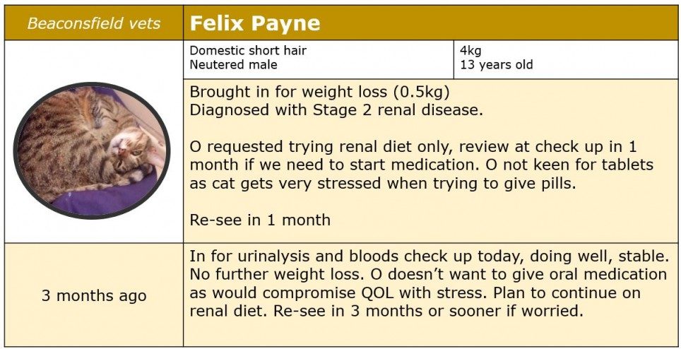
The owner has brought Felix in for his check up, but has been worried about him as recently he has been very lethargic and is not eating well.
You decide to take some bloods to see what's going on.
A blood sample was taken for immediate in-house analysis.
In addition to biochemistry confirming kidney disease you also noticed that a number of haematology values are abnormal. Progressive kidney disease often leads to anaemia.
The haematology results for Felix are below:
Test | Results | Normal range | Units
RBC | 4.0 | 5.0 - 10.0 | x10¹²g/L
Hgb | 9.0 | 10.0 - 15.0 | x10 g/L
MCV | 42.0 | 39.0 - 55.0 | fL
HCT | 25 | 30-45 | %
PLT | 450 | 300 - 800 | x10⁹/L
MCH | 14 | 13-17 | pg
MCHC | 34 | 30-36 | x 10 g/L
Reticulocytes | 0.3 | 0 - 0.6 | %
WBC | 17.2 | 5.5 - 19.5 | x 10⁹/L
Lymphocytes | 28 | 27 - 36 | %
Monocytes | 2 | 0-5 | %
Neutrophils | 47 | 45-64 | %

Anaemia of renal disease is multifactorial. The lack of erythropoietin is the main cause of anaemia in CKD patients
Felix's current symptoms are brought on by a deterioration in his kidney disease.
Felix continues on management for his CKD and the owners are advised to monitor him closely.
Three weeks later, Felix is presented again due to becoming more lethargic and showing signs of weakness. His bloods are checked again and his PCV has dropped to 10%. The owner is aware that CKD is progressive and can’t be cured. Despite the guarded prognosis, the owner is keen to proceed with all treatments possible as Felix had a good quality of life prior to this (despite the CKD).
Therefore, given the further decrease in PCV and the clinical signs shown, the decision is made to administer a blood transfusion. It is important to determine the blood groups of donor and recipient in cats as they have naturally occurring antibodies:
Blood group | Alloantibodies in serum |  | Prevalence
 | Type | Level
A | anti-B | low | Very high (~80%)
B | anti-A | high | low (19-20%)
AB | Absent |  | rare
Felix is blood typed and found to be type B

Giving Felix a blood transfusion
Work out how much blood Felix requires for this transfusion
Calculation for blood transfusions in cats:
Volume of whole blood (ml) = desired PCV rise (%) x Body weight (kg) x 2
- Felix's current PCV is 10% and we want to raise his PCV to 20%
- Felix weights 3.5kg
The practice has access to a staff member's cat, Freddie, who is a laid back Maincoon. He is also blood type B so deemed a suitable donor for Felix
- Freddie weighs 8kg.
- A cat has approx 66mls of blood per kg
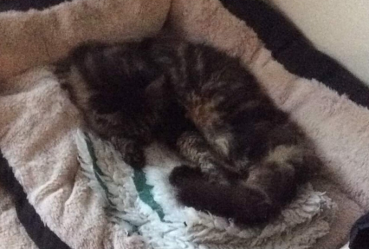
It is safe to collect 10-20% of this animals total blood volume.

Case conclusion
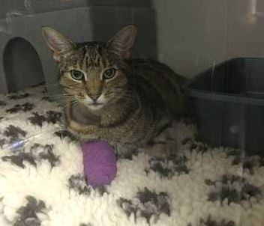
Freddie was able to give the necessary 70ml of blood for Felix. It was just over 10% of Freddie's blood volume so should have little impact on his health.
Felix initially perked up after the transfusion, giving the owners enough time to spoil him. After an evening at home to say goodbye and a meal of sardines, Felix was euthanased at home with his owners.

