Case: Snotty Dog
Meet your patient Jett
Jett is a 5y.o. neutered female GSD with a 10-day history of nasal discharge that is quickly becoming worse. This morning the owner noticed some fresh blood in the discharge. Jett is quieter than usual at home and has a reduced appetite.
On clinical examination you note a mucopurulent bilateral nasal discharge. Jett sneezed twice in the consulting room and produced some blood stained mucous. She resented palpation of her nasal planum; mouth and teeth were unremarkable.
HR, RR and temperature are all normal, no abnormalities detected on auscultation of the heart and lungs.
The three most common differential diagnoses in dogs include
- Foreign body (ie grass, grass seed)
- Nasal Neoplasia
- Fungal infection (ie aspergillosis)

Diagnostic approach
Jett’s owners decide to have bloods taken for haematology and biochemistry. The results were all normal except for a mild leucocytosis.
Jett was anaesthetised for plain radiographs of the skull and rhinoscopy.
The radiograph shows the following:
- Blurring of nasal turbinate pattern due to mucosal inflammation and presence of discharge.
- Areas of overt tubinate osteolysis producing ill-defined lucent areas.
- Patchy, ill-defined areas of increased opacity due to nasal discharge. No specific focus or soft tissue mass cf neoplasia.
- Loss of opacity of nasal septum/vomer shadow suggesting some disruption.
- Normal nasal turbinate pattern in opposite chamber.
To access the annotated version of this radiograph in VetStream click: here
During rhinoscopy white or yellow/green fungal colonies were seen on turbinates (for image see Moores & Walker 2013, Fig 10).
Samples were taken from the plaques as well as biopsies to investigate how invasive the fungal infection is.
A quick in house Lactophenol cotton blue stain of a 'wet' sample from the fungal plaque:
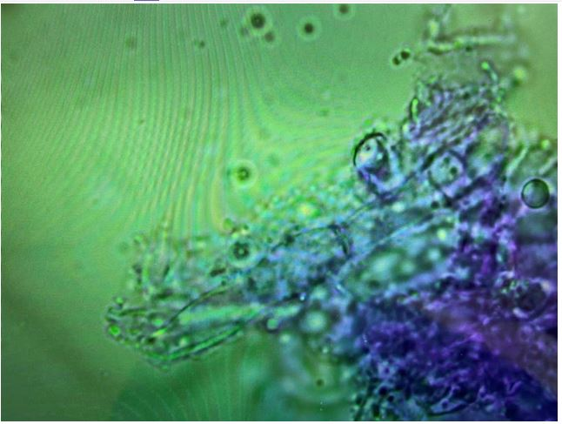

Radiography and rhinoscopy results indicate a fungal infection, you suspect aspergillosis.
Histopathology and culture confirmed a diagnosis of Aspergillus fumigatus for Jett.

Treatment options
The treatment for nasal fungal infections is not straightforward and a variety of options are available. The aspergillosis may have destroyed some of the nasal architecture, destruction of turbinates, thickening of mucosa. Hence dogs often develop chronic rhinitis, meaning they are left with persistent nasal discharge/sneezing. The important thing is to communicate this to the owners before treatment of any kind commences to manage their expectations and make it clear that 100% cure will often not occur in aspergillosis.
- Surgical: debridement of fungal plaques: Debridement (removing as much of the infection as possible under GA) is usually achievable in most cases via a minimally-invasive rhinoscopy. This often improves success of topical treatment.
- Topical treatment: There are several methods described, from non-invasive clotrimazole (anti-fungal) soak including leaving indwelling Foley catheters in place for daily flushing with Enilconazole.
- Oral anti-fungals: Generally poor success if used alone. They are often used in conjunction with topical therapy. Anti-fungal tablets are generally very well tolerated, but approximately 10% of dogs may have side effects with treatment and therefore monitoring with regular clinical assessments and blood tests to check liver function are usually recommended.
Jett underwent surgical debridement of the fungal plaques during rhinoscopy, followed by a non-invasive clotrimazole soak.
Outcomes
Jett’s nasal discharge continued for the following 2 weeks but then began to resolve. Jett's owners are aware that there might have been some long-term damage to the nasal passages, which may make Jett more susceptible to respiratory infections. They will keep an eye on any further sneezing or coughing.

