School of Veterinary Medicine and Science
Sutton Bonington Campus
Loughborough
LE12 5RD

Phone: 01509672332
Fax: +44 (0)115 951 6415
Email: Sutton-Bonington@vla.defra.gsi.gov.uk

PATHOLOGY REPORT
Species: canine | Breed: mixed | Pathology Lab No: UoN D11
Age: 3 years | Sex: female | Previous Lab No(s): N/A
Owner: Fenwick |  | Date received: 23.06.2010
Animal name/ID: Suzy |  | Date of Necropsy: 23.06.2010
Body weight: 16.35kg |  | Photographs:
Referring Veterinary Surgeon:

SB Vets
Main Street
Sutton Bonington
LE12 5ND
Clinical Features/history:

Lymphoma

History:
Home veterinarian - The dog was initially presented to the vet with lump on the neck. She was bright, drinking and eating normally. Dog was a rescue animal and previous medical history unknown. Palpation identified enlarged submandibular and popliteal lymph nodes. Palpation of the swollen area suggested a soft tissue mass. The dog was admitted for FNA of lymph nodes, haematology and thoracic and abdominal radiography. Haematology and radiography were unremarkable. The FNA findings were consistent with lymphoma. Outcome: Dog was euthanized.

Gross Description:

The body examined is of an entire female, 16.35kg, mixed bred in good body condition. There are clipped areas over the jugular vein and the left submandibular lymph node regions and a catheter is still in place in the right cephalic vein.

The submandibular and popliteal lymph nodes are of increased size.

Gross photos are taken and included at the end of the report.

Gross Morphological Diagnoses:
Lymph nodes: Localised Lymphadenopathy, presumed lymphoma.
Thymus: within normal limits..
Liver: within normal limits
Spleen: within normal limits
Kidneys: within normal limits
Subcutis, jugular area of ventral neck: Oedema and haemorrhage.

Comment:
Lymphoma small cell

Histopathology:
Slide 1- Lymph node (popliteal): The architecture is effaced and replaced by atypical lymphoid cell.

Final Diagnosis:
Lymphoma involving submandibular and popliteal lymph nodes.

Pathologist: Alexandra Brower, DVM, DACVP 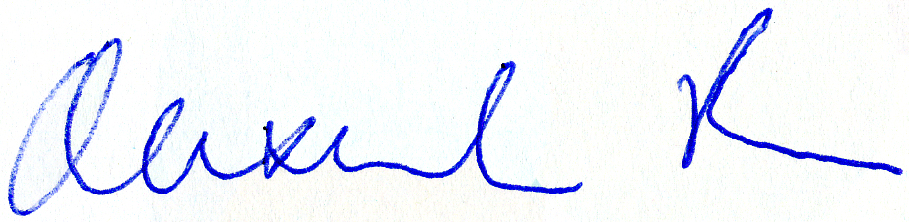
Email: veterinarypathology@nottingham.ac.uk

A charge will not be applied to this case.
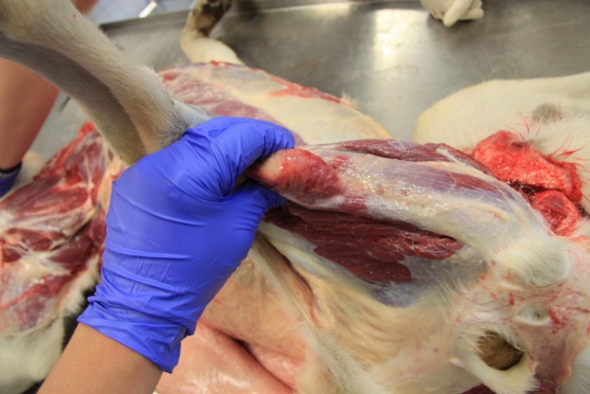

Fig 1. Enlarged popliteal lymph node

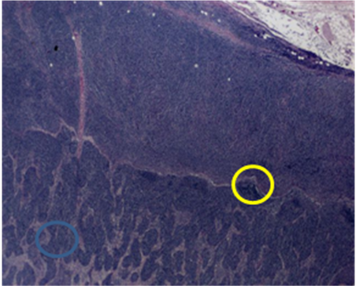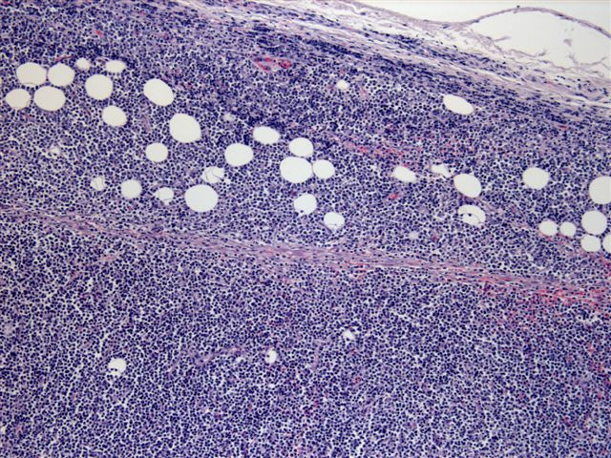
Fig 2 & 3:Histopathology of popliteal lymph node: The normal follicular architecture has been replaced with sheets of blue, corresponding to a clonal population of lymphoid cells. Lymphoid cells have expanded beyond the capsule of the lymph node, residual fat cells entrapped

